ANSI/ASB Standard 017, First Edition

2018

**Standard Practices for Measurement Traceability in Forensic Toxicology**

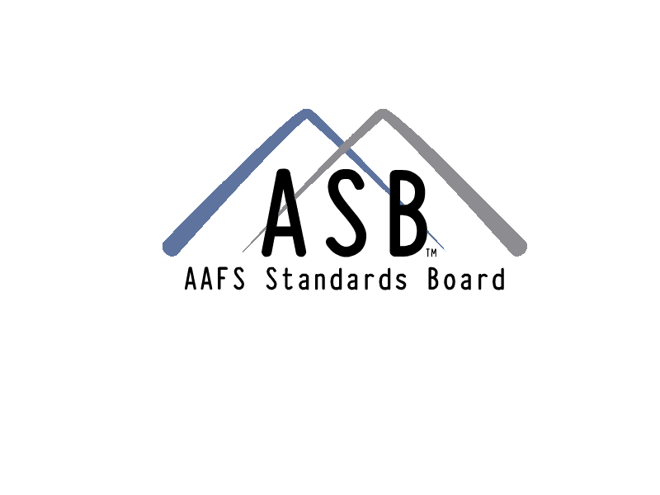 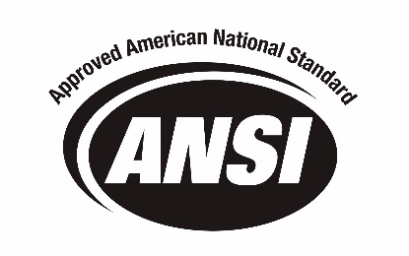

**Standard Practices for Measurement Traceability in   
Forensic Toxicology**

ASB Approved February 2018

ANSI Approved June 2018

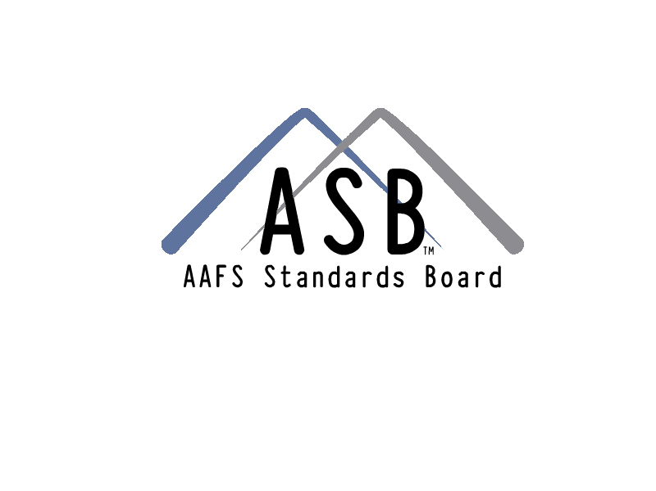

410 North 21st Street  
Colorado Springs, CO 80904

This document may be downloaded for free at: <http://asb.aafs.org/>

*This document is provided by the AAFS Standards Board for free. You are permitted to print and download the document and extracts from the document for your own use, provided that:*

* *you do not modify this document or its related graphics in any way;*
* *you do not use any illustrations or any graphics separately from any accompanying text; and,*
* *you include an acknowledgement alongside the copied material noting the AAFS Standards Board as the copyright holder and publisher.*

*You expressly agree not to reproduce, duplicate, copy, sell, resell, or exploit for any commercial purposes, this document or any portion of it. You may create a hyperlink to* <http://asb.aafs.org> *to allow persons to download their individual, free copy of this document. Your hyperlink must not portray AAFS, the AAFS Standards Board, this document, our agents, associates and affiliates in an offensive manner, or be misleading or false. You may not use our trademarks as part of your link without our written agreement for you to do so.*

*The AAFS Standards Board retains the sole right to submit this document to any other forum for any purpose.*

*Certain commercial entities, equipment or materials may be identified in this document to describe a procedure or concept adequately. Such identification is not intended to imply recommendations or endorsement by the AAFS or the AAFS Standards Board, nor is it intended to imply that the entities, materials, or equipment are necessarily the best available for the purpose.*

*This document is copyrighted © by the AAFS Standards Board, LLC. 2018 All rights are reserved.  
410 North 21st Street, Colorado Springs, CO 80904, asb.aafs.org.*

**Foreword**

This Standard Practices for Measurement Traceability in Forensic Toxicology was developed to provide minimum requirements for establishing measurement traceability in forensic toxicology laboratories. The fundamental reason for establishing traceability of a measurement is to ensure confidence and reliability in forensic toxicological test results. This standard was developed by the Toxicology Subcommittee of the Organizational Scientific Area Committee. It was prepared and finalized as a standard by the Toxicology Consensus Body of the ASB. All hyperlinks and web addresses shown in the document are current as of the publication date of this standard.

**Keywords:** *Measurement Traceability, Calibration, Forensic Toxicology*

**Table of Contents**

1 Scope 1

2 Normative References 1

3 Terms and Definitions 1

4 General Measurement Traceability 2

4.1 Background 2

4.2 Requirements for Measurement Traceability 4

5 Measurement Traceability Requirements for Toxicology 6

6 Equipment 7

6.1 General 7

6.2 Calibration of Analytical Equipment 7

6.3 Other Equipment 8

7 Conformance 8

Annex A (informative) Bibliography 9

Standard Practices for Measurement Traceability in Forensic Toxicology

# Scope

This standard defines the minimum requirements for establishing measurement traceability in forensic toxicology laboratories.

# Normative References

The following references are documents that are indispensable for the application of the standard. For dated references, only the edition cited applies. For undated references, the latest edition of the referenced document (including any amendments) applies.

International Bureau of Weights and Measures (BIPM)-International Committee for Weights and Measures (CIPM) *Mutual Recognition Arrangement* [1]

International Laboratory Accreditation Cooperation (ILAC), ILAC P10:01/2013 *ILAC Policy on Traceability of Measurement Results* [2]

International Laboratory Accreditation Cooperation (ILAC) *Mutual Recognition Arrangement* 3

International Organization for Standardization (ISO), ISO/IEC 17025:2005 *General requirements for the competence of testing and calibration laboratories* (Geneva, Switzerland: ISO, 2005) [3]

International Organization for Standardization (ISO), ISO Guide 34:2009 *General requirements for the competence of reference material producers* (Geneva, Switzerland: ISO, 2009) 4

International Organization for Standardization (ISO), ISO 17034:2016 *General requirements for the competence of reference material producers* (Geneva, Switzerland: ISO, 2016) 4

Joint Committee for Guides in Metrology (JCGM), *International vocabulary of metrology – Basic and general concepts and associated terms* (VIM)*,* 3rd ed*.* (Sèvres, France: International Bureau of Weights and Measures [BIPM]-JCGM 200, 2012) (2008 with minor corrections) [4]

# Terms and Definitions

For purposes of this document, the following definitions and acronyms apply.

* + 1. **accreditation [5]**

Third party evaluation of a forensic science service provider based on a particular standard(s), other relevant documents and attestation of competence to carry out specific tasks.

* + 1. **accuracy [6]**

Closeness of agreement between a measured quantity value and a true quantity value of a measurement.

* + 1. **calibration**Operation that, under specified conditions, establishes a relation between the quantity value and corresponding indications.
    2. **calibrator 7**Measurement standard used in calibration.
    3. **Certified Reference Material [7]   
       CRM**

Reference material characterized by a metrologically valid procedure for one or more specified properties, accompanied by a certificate that provides the value of the specified property, its associated uncertainty, and a statement of metrological traceability.

* + 1. **control**Material of known composition that is analyzed along with unknown samples(s) in order to evaluate the performance of an analytical procedure.
    2. **decision point**

Administratively defined cutoff or concentration that is at or above the method’s limit of detection or lower limit of quantitation and is used to discriminate between a negative and positive test result.

* + 1. **Limit of Detection**

**LOD**

An estimate of the lowest concentration of an analyte in a sample that can be reliably differentiated from blank matrix and meets identification criteria for the analytical method.

* + 1. **Lower Limit of Quantitation**

**LLOQ**

An estimate of the lowest concentration of an analyte in a sample that can be reliably measured with acceptable bias and precision.

* + 1. **forensic science service provider**

A forensic science agency or forensic science practitioner providing forensic science services.

* + 1. **mass reference standard**

A standard having the highest metrological quality available at a given mass, from which the measurements made at that mass are derived.

**measurement traceability** 7

Property of a measurement result whereby the result can be related to a reference through a documented unbroken chain of calibrations, each contributing to the measurement uncertainty.

NOTE This is sometime referred to as metrological traceability.

**reference material**

Material, sufficiently homogeneous and stable with reference to specified properties, which has been established to be fit for its intended use in a measurement or in examination of nominal properties.

# General Measurement Traceability

* + 1. **Background**

**4.1.1** Some measurement processes require only a single step, whereas others may require more than one step.

**Measurement**: process of experimentally obtaining one or more quantity values that can reasonably be attributed to a quantity.7

Importantly, “process” is the first word in the definition of measurement. Measurement relates to the whole process of obtaining a quantity value.

Related terms:

**Quantity**: property of a phenomenon, body, or substance, where the property has a magnitude that can be expressed as a number and a reference.7

**Quantity Value**: number and reference together expressing magnitude of a quantity.7

Quantity Value example (Toxicology):

Blood alcohol content: 0.158 grams of ethanol per 100 mL of blood.

* + 1. Measurements are made in different ways in testing and calibration processes. A measurement may be:
       1. a reported test result;
       2. a reported calibration result; or
       3. a quantitative decision point (cutoff) that results in a qualitative test report

In all of these scenarios, the measurement(s) may be used as the basis for a conclusion, an interpretation, or an opinion.

NOTE A measurement may also be made during the testing or calibration process, but not reported to the customer.

* + 1. Measurement traceability can be characterized by the following essential elements.[8]
       1. *Unbroken Chain of Comparisons*– A documented system of comparisons with each step having the essential elements of metrological traceability going back to a stated reference acceptable to the parties, usually a national or international standard.
       2. *Documented Measurement Uncertainty*– The measurement uncertainty for each step in the traceability chain must be calculated according to defined methods and must be stated so that an overall uncertainty for the whole chain may be calculated.
       3. *Documented Measurement Procedure*– Each step in the chain must be performed according to documented, generally-accepted procedures and the results must be documented.
       4. *Technical Competence*– The laboratories or bodies performing one or more steps in the chain must maintain and supply evidence of technical competence (e.g., by maintaining appropriate training records, participating in inter-laboratory comparisons, and by demonstrating that they are accredited by a recognized accreditation body).
       5. *Realization of SI Units*– The chain of comparisons must, where possible, end at the realization of the International System of Units (SI).
       6. *Documented Calibration Intervals*– Calibrations must be repeated at established and appropriate intervals to preserve metrological traceability; and
       7. *Measurement Assurance*– A proper measurement assurance program [however named] must be established to ensure the validity of the measurement process and to ensure the calibration status of equipment, reference standards and reference materials.
  1. **Requirements for Measurement Traceability**

**4.2.1 General**

Forensic science service providers establish traceability of a measurement process by making one or more measurements using equipment that has been calibrated with established metrological traceability and/or through the use of certified reference materials in the test or calibration method.

For equipment and certified reference materials used to establish and maintain measurement traceability, proper handling and storage procedures which meet or exceed manufacturer’s recommendations must be followed.

* + 1. **Calibration Service Provider**

If traceability of a measurement will be established through the calibration of equipment used to make the measurement, then this calibration shall be performed by an appropriately accredited calibration service supplier that, if available, is either:

* + - 1. a National Metrology Institute (NMI) that is a signatory to the BIPM - CIPM *Mutual Recognition Arrangement*, with the calibration to be performed listed in Appendix C of the BIPM *Key Comparison Database* (KCDB); or
      2. a service supplier accredited to ISO/IEC 17025:2005 by an accrediting body that is a signatory to the International Laboratory Accreditation Cooperation (ILAC) *Mutual Recognition Arrangement*, with the calibration to be performed listed in a scope of accreditation.

If an appropriately accredited calibration service supplier is not available (as defined above), then the forensic science service provider shall perform their own evaluation. This evaluation shall ensure the external service supplier meets the competence, measurement traceability, and measurement capability requirements of ISO/IEC 17025:2005 or in the *ILAC Policy on the Traceability of Measurement Results*.[9] The forensic science service provider shall keep objective evidence of this evaluation. The forensic science service provider shall perform a re-evaluation of services at least every two years.

* + 1. **Calibration Program**

The forensic science service provider shall identify all equipment in a calibration program, however named, that requires calibration to establish measurement traceability, either totally or partially. The documentation shall:

* + - 1. establish the interval for calibration;
      2. delineate if intermediate checks of the calibration status are required between calibrations and if so, the schedule and procedure for those intermediate checks; and
      3. require calibration of new equipment of this type (e.g., balance, pipette) prior to use of the equipment in testing, calibration or inspection work.

See Section 6 for minimum calibration requirements.

* + 1. **Certified Reference Materials**

If traceability of a measurement will be established through reference material, the forensic science service provider shall establish it through the use of one or more certified reference material(s) (CRM). If available, the CRM shall be obtained by the forensic science service provider from a supplier that is either:

* + - 1. a National Metrology Institute (NMI) that is a signatory to the BIPM - CIPM *Mutual Recognition Arrangement,* with the CRM to be purchased included in the BIPM key comparison database (KCDB); or
      2. an accredited Reference Material Producer that is accredited to ISO Guide 34:2009 or ISO 17034:2016 by an accrediting body that is a signatory to a mutual or multilateral recognition arrangement in an ILAC recognized regional accreditation cooperation or the ILAC *Mutual Recognition Arrangement*, with a scope of accreditation covering the CRM.

If a CRM is not available to the forensic science service provider from a supplier that meets the above requirement, then the forensic science service provider shall perform an evaluation of the CRM supplier. This evaluation shall ensure the CRM supplier meets the competence, measurement traceability, and measurement capability requirements of ISO/IEC 17025:2005 or in the *ILAC Policy on the Traceability of Measurement Results*. The forensic science service provider shall keep objective evidence of this evaluation. The forensic science service provider shall perform a re-evaluation of services at least every two years.

* + 1. **Modifications to Reference Materials**

If a reference material used to establish traceability, whether certified or not, is diluted, such as a stock or working solution, then the equipment used shall be calibrated as delineated in Section 6.

# Measurement Traceability Requirements for Toxicology

**5.1** Forensic toxicology methods are typically categorized as screening, qualitative confirmation/identification, or quantitative. Measurement traceability shall be established by the forensic toxicology laboratory through the use of one or more metrologically-prepared calibrators.[10] Additionally, a laboratory may choose to use controls that are metrologically-prepared.

**5.2** The following (5.2.1 and 5.2.2) measurement traceability requirements shall be followed by forensic toxicology laboratories for their analytical methods.

* + 1. Measurement traceability shall be established during method validation and routine analysis of cases for:

1. all screening procedures with an established decision point concentration;

NOTE See 5.2.2 for immunoassay-based screening procedures

1. qualitative confirmation/identification methods with an established decision point concentration;
2. quantitative methods.
   * 1. Measurement traceability for immunoassay-based screening procedures shall be established during method validation or during routine analysis of cases. Manufacturer kits used in immunoassay-based screening procedures may lack measurement traceability; therefore, laboratories may establish measurement traceability through use of CRMs while initially validating the method and confirming traceability through use of in-house prepared controls.

# Equipment

**6.1 General**

The equipment listed in Section 6.2 is commonly used in forensic toxicology laboratories and shall be calibrated by appropriately accredited calibration service suppliers that meet those requirements in Section 4.2.2.

Documentation of the accredited calibration service suppliers shall be maintained by the forensic toxicology laboratory. Equipment shall be calibrated prior to use, and the laboratory shall have a procedure that includes the frequency of calibration and acceptability/tolerance specifications. Calibration documentation shall include the date the calibration is performed, the calibration status and the date the next calibration is due. Equipment shall be calibrated at a point or within a range consistent with typical use.

The forensic toxicology laboratory shall evaluate whether intermediate checks of the calibration status are necessary based on, but not limited to, the frequency of use, work volume, occurrence of unexpected shutdown and equipment maintenance. If intermediate checks are performed, the policy and procedure shall include the frequency and specifications for intermediate checks and actions to be taken when the specifications are not met. Intermediate checks shall be carried out using calibrated equipment (e.g., mass reference standards, equipment used to monitor environmental conditions).

* 1. **Calibration of Analytical Equipment** 
     1. **Analytical Balances**

Analytical balances shall be calibrated at least annually by an appropriately accredited calibration service supplier.

* + 1. **Reference Standards**

Reference standards (e.g., calipers, rulers, mass reference standards) shall be calibrated at least once every three years by an appropriately accredited calibration service supplier. Any adjustments of reference standards shall only be conducted by an accredited calibration service supplier, and the reference standards shall be calibrated before and after any adjustment. Reference standards used to verify the accuracy of equipment shall be dedicated for this purpose, unless the forensic toxicology laboratory has demonstrated that their integrity as reference standards are maintained.

* + 1. **Volumetric Glassware**

Class A volumetric glassware shall be used for the preparation of calibrators and shall be calibrated by an accredited calibration service supplier prior to use. Volumetric glassware used in the preparation of calibrators shall be dedicated for this purpose, and shall be maintained and stored as to protect its integrity. After initial calibration, scheduled recalibration shall recur at least once every ten years by an appropriately accredited calibration service supplier.

* + 1. **Pipettes, Diluters, and Syringes**

All pipettes, pipette diluters, automatic diluters, and syringes used for the preparation of calibrator solutions that require measurement traceability or in sample preparation (e.g. sample aliquoting and other steps that affect overall measurement uncertainty) shall be calibrated at least annually by an appropriately accredited calibration service supplier. Autosampler syringes used for sample introduction to analytical instrumentation (e.g., gas chromatograph, liquid chromatograph, or immunoassay) do not require calibration.

* + 1. **Thermometers**

Thermometers used to verify proper storage of certified reference materials shall be calibrated at least every two years by an appropriately accredited calibration service supplier. Other thermometers that do not significantly affect the accuracy and validity of the test result (e.g., thermometers used in water baths and heat blocks) do not require calibration to establish measurement traceability.

* + 1. **Breath Alcohol Calibration Equipment**

Simulator thermometers, multi-meters and barometers, as applicable, shall be calibrated at least every two years by an appropriately accredited calibration service supplier, as defined in 4.2.2.

Sections 6.2.1 to 6.2.5 apply to equipment used in preparation of breath alcohol reference materials used in a breath alcohol calibration method.

* 1. **Other Equipment**

General laboratory equipment used during sample preparation (e.g., centrifuges, rotators, shakers, water baths, evaporators, extraction manifolds, and heating blocks)that does not significantly affect the accuracy and validity of the test result, do not require calibration to establish measurement traceability. A forensic toxicology laboratory may choose to use calibration or verification as a maintenance procedure to ensure proper functioning of the equipment.

# Conformance

Documentation to verify conformance with the above requirements shall be maintained by the forensic toxicology laboratory for a minimum of five years after expiration and shall be made available to auditors upon request.

# Annex A (informative)

**Bibliography**

1. ASCLD/LAB *Guidance on Measurement Traceability – Measurement Assurance*[www.ascld-lab.org/](http://www.ascld-lab.org/)
2. ASCLD/LAB *Policy on Measurement Traceability* [www.ascld-lab.org/](http://www.ascld-lab.org/)
3. ASTM International E542-01 *Standard Practice for Calibration of Laboratory Volumetric Apparatus* [www.astm.org](http://www.astm.org/)
4. *Eurachem Terminology in Analytical Measurement – Introduction to VIM 3* <https://www.eurachem.org/index.php/publications/guides/terminology-in-analytical-measurement>
5. The National Institute of Standards and Technology (NIST) definition of “internal measurement assurance program” [www.nist.gov/traceability/index.cfm](http://www.nist.gov/traceability/index.cfm)
6. The National Institute of Standards and Technology (NIST) *Sample Procedure for Method Validation* <https://www.nist.gov/document/sapmethodvalidation2016-12-21doc>
7. The National Institute of Standards and Technology (NIST) *Important Technical Guidance on Glassware* <https://www.nist.gov/sites/default/files/documents/2017/05/09/H-008.pdf>
8. International Organization for Standardization (ISO). ISO/IEC 9000:2015 *Quality Management Systems—Fundamentals and Vocabulary* (Geneva, Switzerland) ISO documents available for purchase at <http://www.iso.org/iso/home/store/catalogue_ics.htm> or from other authorized distributors
9. International Organization for Standardization (ISO). ISO/IEC 17000:2004 *Conformity Assessment—Vocabulary and General Principles* (Geneva, Switzerland) ISO documents available for purchase at <http://www.iso.org/iso/home/store/catalogue_ics.htm> or from other authorized distributors
10. International Organization for Standardization (ISO), ISO Guide 33: 2015 *Reference Materials – Good Practice in Using Reference Materials* (Geneva, Switzerland) ISO documents available for purchase at <http://www.iso.org/iso/home/store/catalogue_ics.htm> or from other authorized distributors
11. International Organization for Standardization (ISO), ISO Guide 30: 2015 *Reference Materials – Selected Terms and Definitions* (Geneva, Switzerland) ISO documents available for purchase at <http://www.iso.org/iso/home/store/catalogue_ics.htm> or from other authorized distributors
12. International Bureau of Weights and Measures (BIPM) *Key Comparison Database* (KCDB), Appendix C <http://kcdb.bipm.org/appendixC/>
13. National Commission on Forensic Science, *Defining Forensic Science and Related Terms* <https://www.justice.gov/ncfs/file/786571/download>
14. Scientific Working Group on Forensic Toxicology (SWGTOX) *Standard on the Accreditation of Forensic Toxicology Laboratories* (Revision 1), February 22, 2014 <http://www.swgtox.org/documents/SWGTOX_Accreditation.pdf>

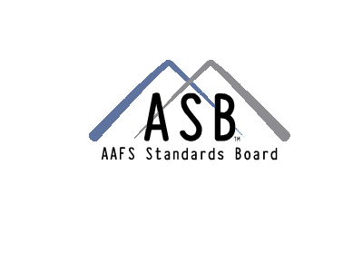

Academy Standards Board

410 North 21st Street

Colorado Springs, CO 80904

<http://asb.aafs.org/>

1. More information about the BIPM is available at: <http://www.bipm.org/en/cipm-mra/>
2. ILAC document available for download at: [http://ilac.org](http://ilac.org/?ddownload=840)
3. ISO documents available for purchase at: <http://www.iso.org/iso/home/store/catalogue_ics.htm> or from other authorized distributors
4. VIM available for download at: <http://www.bipm.org/en/publications/guides/vim.html>
5. From *SWGTOX Standard on the Accreditation of Forensic Toxicology Laboratories.*
6. From Joint Committee for Guides in Metrology (JCGM), *International vocabulary of metrology – Basic and general concepts and associated terms* (VIM)*,* 3rd ed*.* (Sèvres, France: International Bureau of Weights and Measures [BIPM]-JCGM 200, 2012) (2008 with minor corrections)
7. From ISO Guide 30: 2015
8. See “Sample Procedure for Method Validation” at <https://www.nist.gov/document/sapmethodvalidation2016-12-21doc>
9. Reference to ILAC P10.
10. Calibrators may be undiluted CRM(s) or calibrators prepared using appropriately calibrated equipment and CRMs, or reference material(s) (RM) shown to be fit for purpose, as defined in 4.2.4.